# Contributors

Sam - version 1.0

Paolo - version 2.0

# High Level Overview

## Frames

A frame is rendered at regular intervals (e.g. 30 frames could be rendered every second). Consider the game to be split into a fixed number of frames:

|Frames| = seconds in game * frame rate

These frames range from 0 up to the final frame of the game. We capture data about the player every Update and store it in a data structure at the frame they’re at [1].

## Tails

These are replays of the players. If you visit the past, you’ll see tails replaying the same actions that the head originally made at that point in time. This is achieved by simply checking the frame you’re visiting and retrieving the saved states from the database. We then set the corresponding attributes of the tail objects.

## Realities

At the start of the game, every player begins at frame 0 and moves through time together. In other words, they are in the same “reality”. However, each player is allowed to move to any frame in elapsed time individually. This means that as the game progresses, players may move to different frames in the game and therefore exist in different realities.

# Implementation

## Game Controller

This stores the Player States database and the Reality Manager. It is the interface for interacting with them.

## Player States [1]

This is the data structure for storing the players’ states every frame. It is an array of linked lists. The index of the array is the frames of the game. Each player’s state is simply an item in the linked list.

## RealityManager [2]

The RealityManager keeps track of which reality each player is in (their perceived frame) as well as pointers to which frames they should be writing to in the database. These two things are different because although you perceive yourself travelling backwards through time, other people will see your tail disappearing in the reality you just left (and reappearing in the reality you arrive in). It’s this that we need to store in the Player States.

# Screenshots

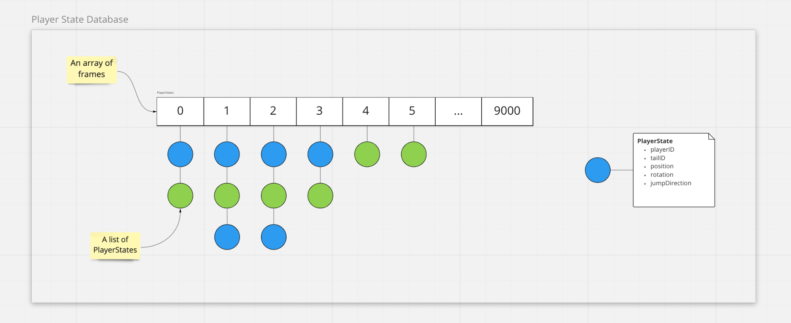

*Image 1: The player state database as an array of lists.*

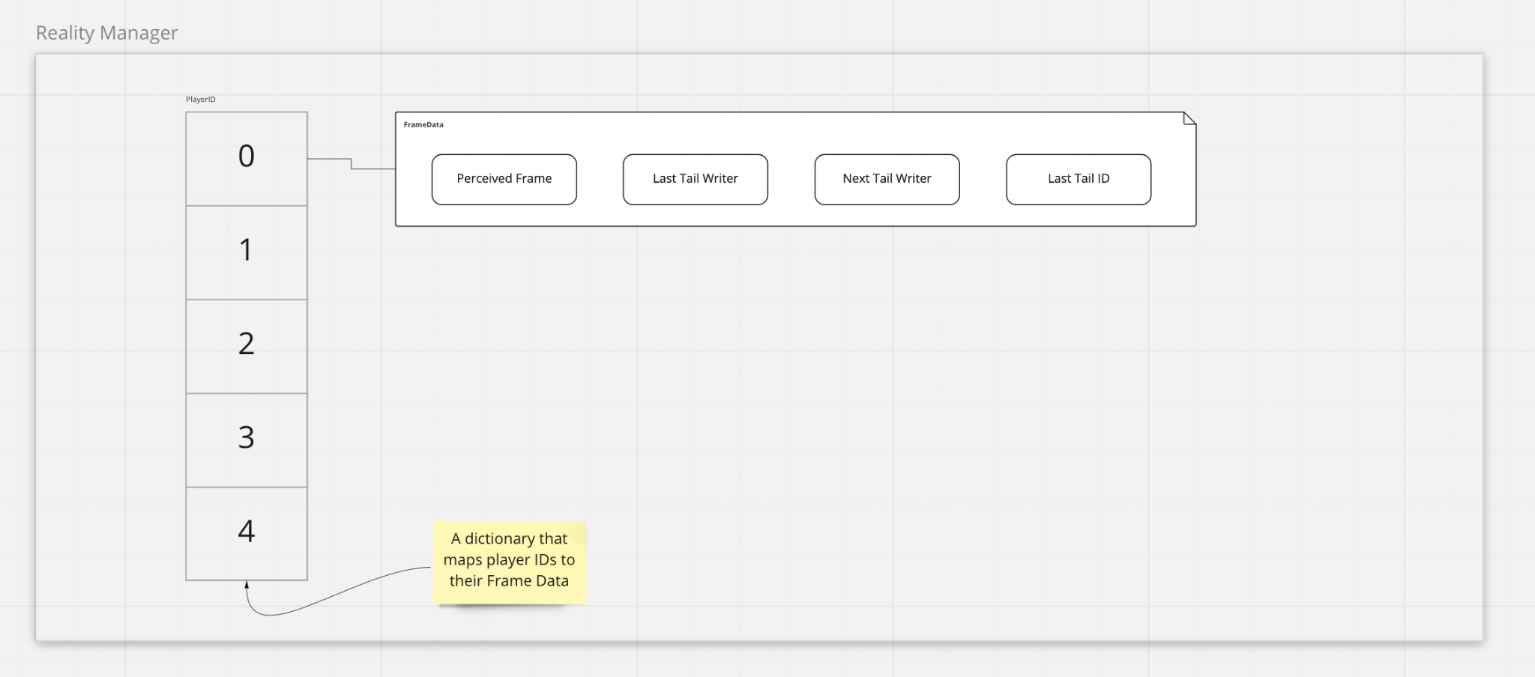

*Image 2: The reality manager, which keeps track of each player’s current frames.*